

AI-Based Medical Inventory and Prescription Management System

A CAPSTONE PROJECT REPORT

A Capstone Project Report submitted in partial fulfilment of the requirements for the Course of

CSA0202 C-PROGRAMMING

to the award of the degree of

BACHELOR OF TECHNOLOGY IN
COMPUTER SCIENCE AND ENGINEERING
(ARTIFICIAL INTELLIGENCE AND MACHINE LEARNING)

Submitted by

KEERTHAN M (1925260006)
MITHRAN K (1912260188)
MITHUN KRISHNA S (1912260101)
MOHAMED ASHFAQ M (1913260005)
JESHONE PRINCE M (1912260055)

Under the Supervision of Guide Name
SIMATS ENGINEERING
Saveetha Institute of Medical and Technical Sciences Chennai-602105

SEPTEMBER 2026

SIMATS ENGINEERING
Saveetha Institute of Medical and Technical Sciences Chennai-602105

BONAFIDE CERTIFICATE

This is to certify that the Capstone Project entitled “AI-Based Medical Inventory and Prescription Management System” has been carried out by KEERTHAN M(1925260006), MITHRAN K (1912260188),MITHUN KRISHNA S (1912260101),MOHAMED ASHFAQ M (1913260005),JESHONE PRINCE M (1912260055)
under the supervision of S. Nanthini and is submitted in partial fulfilment of the requirements for the current semester of the B.Tech COMPUTER SCIENCE AND ENGINEERING (ARTIFICIAL INTELLIGENCE AND MACHINE LEARNING) program at Saveetha Institute of Medical and Technical Sciences, Chennai.

COURSE COORDINATOR COURSE FACULTY
Dr. S. Anushya, Dr. S. Nanthini,
Professor, Professor,
Computer Science and Engineering Dept, Cybersecurity Dept,
SIMATS Engineering, SIMATS Engineering,
SIMATS, Chennai – 602105. SIMATS, Chennai – 602105.

SIMATS ENGINEERING
Saveetha Institute of Medical and Technical Sciences Chennai-602105

DECLARATION

We, Keerthan M, Mithran K,Mithun Krishna S, Mohamed Ashfaq M,Jeshone Prince M of the CSE-AIML, ECE, ECE, EEE, ECE Departments, SIMATS Engineering, Saveetha Institute of Medical and Technical Sciences, Chennai, hereby declare that the Capstone Project Work entitled “AI-Based Medical Inventory and Prescription Management System” is the result of our own bonafide efforts. To the best of our knowledge, the work presented herein is original, accurate, and has been carried out in accordance with the principles of engineering ethics and academic integrity. All sources, references, data, and other materials used in the project have been appropriately acknowledged. We further declare that the data, results, analysis, and findings presented in this report have not been fabricated, falsified, or manipulated. Any external tools, software, datasets, computational resources, or AI-assisted tools used during the project have been appropriately disclosed. We confirm that all applicable ethical, academic, institutional, and professional requirements have been duly followed throughout the planning, execution, analysis, and documentation of the project.

Place: SIMATS Engineering
Date: 01-09-2026

Signature of the Students with Names

SIMATS ENGINEERING
Saveetha Institute of Medical and Technical Sciences Chennai-602105

Individual Contribution Statement

Student Name / Register No. | Specific  Responsibilities | Design & Development Contribution | Testing & Analysis  Contribution | Report Contribution | Approx.  Contribution (%)
KEERTHAN M 1925260006 | System design, C implementation, integration | Core modules, data structures, integration testing | Integration testing | Ch. 1, Ch. 3, Ch. 4 | 20%
MITHRAN K 1912260188 | Inventory and stock workflow | Stock/expiry validation and test cases | Stock/expiry validation and test cases | Ch. 2, Ch. 4 | 20%
MOHAMED ASHFAQ M 1913260005 | Billing and transaction workflow | Billing verification and outputs | Billing verification and outputs | Ch. 3, Ch. 4 | 20%
JESHONE PRINCE M 1912260055 | Prescription and records workflow | Prescription module testing | Prescription module testing | Ch. 3, Ch. 5 | 20%
MITHUN KRISHNA S 1912260101 | Reporting and restocking logic | Report and recommendation verification | Report and recommendation verification | Ch. 4, Ch. 5 | 20%
Total |  |  |  |  | 100%

ABSTRACT

Pharmacies require accurate and timely management of medicine records, stock quantities, billing transactions, prescriptions, and expiry dates. Manual registers and disconnected spreadsheets can make these activities slow, error-prone, and difficult to monitor. The proposed AI-Based Medical Inventory and Prescription Management System, presented through the MediCore Pharmacy Operations System, provides an integrated approach to these common pharmacy-management challenges.
The system is designed around C programming concepts such as structures for medicine and transaction records, arrays for collections of records, functions for modular processing, file handling for persistent storage, loops for record traversal, and switch-case statements for menu-driven navigation. The project covers login, medicine management, stock management, billing, prescription management, expiry tracking, reports, and rule-based restocking recommendations.
The restocking component is intentionally explainable rather than machine-learning based. It evaluates current stock against a reorder level and considers sales activity before generating a RESTOCK or MONITOR recommendation. The demonstration material also includes a pharmacy dashboard and screens for inventory, reports, expiry tracking, prescriptions, and billing.
Testing material supplied with the project contains twelve functional test cases covering authentication, medicine operations, billing, low-stock alerts, expiry checks, reporting, and AI-assisted restocking. The supplied test table records all twelve cases as PASS. Performance material in the presentation reports response times below two seconds for the demonstrated operations and high calculation accuracy; these values are treated as project-demonstration metrics rather than independent laboratory benchmarks.
Keywords: Pharmacy Management, C Programming, Inventory Management, Expiry Tracking, Prescription Management, Rule-Based Restocking

TABLE OF CONTENTS

Sl.  No | Title | Page  No
i | CERTIFICATE FROM THE SUPERVISOR | ii
ii | DECLARATION BY THE CANDIDATE | iii
Iii | INDIVIDUAL CONTRIBUTION STATEMENT | iv
iv | ABSTRACT | v
v | LIST OF FIGURES | vi
vi | LIST OF TABLES | vii
vii | LIST OF ABBREVIATIONS | viii
1 | CHAPTER 1: Introduction | 1
2 | CHAPTER 2: Literature Review | 3
3 | CHAPTER 3: Engineering Design & Trade-offs, Sustainability,  Ethics, Safety, Risk & Security | 4
4 | CHAPTER 4: Implementation, Testing & Results, Project  Management | 6
5 | CHAPTER 5: Conclusion & Reflection | 9
 | References | 11

CHAPTER 1
INTRODUCTION AND ENGINEERING PROBLEM

1.1 Background ...................................................
Pharmacy operations depend on the accurate availability of medicines, correct billing, timely identification of low stock, safe handling of expiry dates, and reliable prescription records. In a manual environment, pharmacists may have to search through registers, calculate bill totals separately, and repeatedly verify quantities and dates. These activities increase the possibility of human error and make it difficult to obtain a consolidated view of the pharmacy.
MediCore Pharmacy Operations System was developed as a practical pharmacy-management solution that brings these activities into a connected workflow. The project presentation identifies inventory management, stock monitoring, billing, prescription management, expiry tracking, reports, and AI-assisted restocking as the principal functional areas.

1.2 Need for the Project .........................................
The need for the system arises from the combined operational burden of maintaining medicine records, monitoring quantities, preparing bills, checking expiry dates, retrieving prescription information, and preparing reports. A digital workflow can reduce repeated manual calculations and make important conditions such as low stock and approaching expiry easier to notice.
• Reduce manual effort in maintaining medicine and transaction records.
• Improve visibility of current stock and reorder conditions.
• Reduce billing calculation and quantity-entry errors.
• Provide organized prescription information and faster retrieval.
• Identify expired or soon-to-expire medicines.
• Provide simple decision support for restocking.

1.3 Problem Statement ............................................
Small pharmacies may rely on manual registers, disconnected spreadsheets, or basic billing tools that do not provide a unified view of inventory, prescriptions, expiry status, sales, and restocking decisions. The engineering problem is therefore to develop an affordable and understandable system that integrates these functions while remaining suitable for implementation using core C programming concepts and simple persistent storage.

1.4 Project Aim ..................................................
To design and implement an integrated pharmacy operations system using C programming that manages medicine records, stock, billing, prescriptions, expiry information, reports, and explainable rule-based restocking recommendations.

1.5 Project Objectives ...........................................
Table 1.1 – Project Objectives
Objective | Measurable / Intended Outcome
O1 | Design a centralized medicine catalogue with add, update, delete, and search operations.
O2 | Monitor stock quantities and identify medicines below their reorder level.
O3 | Generate itemized bills, calculate totals and tax, and update stock after sales.
O4 | Track expiry dates and highlight medicines approaching or past expiry.
O5 | Store and retrieve prescription-related information in an organized manner.
O6 | Generate inventory, sales, medicine-list, and restocking reports.
O7 | Provide transparent restocking suggestions using stock level and sales information.

1.6 Scope ........................................................
The current scope focuses on small pharmacies and medical stores. It covers medicine inventory, stock monitoring, billing, prescription information, expiry tracking, report generation, and rule-based restocking support. The system is intended as an academic prototype and does not claim to replace professional pharmacy judgment or provide clinical advice.
Future scope includes barcode and QR-code scanning, cloud-based multi-location inventory, mobile access, hospital integration, automated supplier ordering, and advanced machine-learning demand prediction.

1.7 Expected Engineering Outcome .................................
The expected outcome is a working pharmacy-management prototype demonstrating an integrated operational workflow. The implementation should accept user actions, process medicine and transaction records, preserve data, generate clear status information, and provide testable restocking recommendations. The project also demonstrates the application of C structures, arrays, functions, loops, conditional statements, switch-case navigation, and file handling.

System Workflow

Table 1.2 – System Workflow

Stage | Activity | Output
1 | Login / authentication | Authorized workspace access
2 | Medicine management | Medicine records maintained
3 | Stock management | Quantity and low-stock status updated
4 | Billing | Bill total calculated and stock adjusted
5 | Prescription management | Prescription records stored/retrieved
6 | Expiry tracking | Expired / expiring medicines identified
7 | Reports | Inventory and sales information summarized
8 | AI-assisted restocking | RESTOCK / MONITOR recommendation generated

CHAPTER 2
LITERATURE REVIEW AND EXISTING SOLUTIONS

2.1 Review Method ................................................
The review was based on the existing-system categories and related-work material included in the project presentation, together with the technical references used for the C implementation. The review considered manual pharmacy records, computerized billing and inventory systems, database-backed systems, cloud-based solutions, and AI-assisted inventory approaches.

2.2 Review of Existing Work ......................................
The project presentation describes an evolution from paper-based inventory toward computerized, database-backed, cloud-based, and AI-assisted pharmacy systems. Manual systems are simple to start with but require repeated physical checking. Basic computerized systems improve billing and record keeping, while cloud systems provide broader accessibility at the cost of greater infrastructure and connectivity requirements.
The presentation also identifies AI-assisted inventory as a later stage in this evolution. For the present academic project, a transparent rule-based approach was selected instead of machine learning so that the decision logic can be implemented and verified directly in C.

2.3 Comparative Analysis .........................................
Table 2.1 – Comparative Analysis of Existing Approaches

Existing Approach | Advantages | Limitations | Relevance to MediCore
Manual registers | Low initial cost; simple | Slow search; errors; poor real-time visibility | Problem addressed directly
Spreadsheet / basic billing | Faster calculation and storage | Limited integration; manual stock and expiry checking | MediCore integrates more functions
Database / cloud pharmacy system | Centralized data; scalable access | Higher infrastructure and maintenance requirements | Useful future direction
AI-assisted inventory | Can support demand-based decisions | More complex data and model requirements | Simplified through explainable rules
MediCore prototype | Integrated workflow; low infrastructure; C-based | Prototype scale; limited advanced forecasting | Selected for academic implementation

2.4 Research / Engineering Gap ...................................

The project identifies a gap between simple academic C programs and full-scale pharmacy-management platforms. The proposed work focuses on the middle ground: an integrated prototype that demonstrates multiple real-world pharmacy operations while remaining understandable, testable, and implementable using core C programming concepts.

2.5 Proposed Contribution ........................................

The proposed contribution is the integration of medicine management, stock monitoring, billing, prescriptions, expiry tracking, reports, and explainable restocking recommendations in a single workflow. The restocking feature provides a transparent reason for its recommendation, which makes it suitable for demonstration and verification in an academic setting.

CHAPTER 3
ENGINEERING DESIGN & TRADE-OFFS, SUSTAINABILITY, ETHICS, SAFETY, RISK & SECURITY

3.1 Requirements .................................................

Stakeholder / User Requirements
Table 3.1 – Stakeholder / User Requirements
Stakeholder | Requirement
Pharmacist / Staff | Fast medicine search, stock visibility, billing, expiry alerts and prescription access.
Pharmacy Administrator | Inventory status, reports, alerts and restocking information.
Customer | Accurate billing and improved availability of required medicines.
Project Team | Practical application of C programming, testing and modular system design.

Functional & Non-Functional Requirements
Table 3.2 – Functional and Non-Functional Requirements
Requirement | Type | Measurable Target
Add, update, delete and search medicine records | Functional | Operation produces correct record result
Monitor stock and reorder level | Functional | Low/out-of-stock status displayed when condition occurs
Generate bill and calculate tax | Functional | Subtotal, tax and total displayed consistently
Track expiry status | Functional | Expired / expiring-soon medicines identified
Store and retrieve prescriptions | Functional | Record can be saved and retrieved
Generate reports | Functional | Inventory/sales/recommendation information displayed
Restocking recommendation | Functional | RESTOCK or MONITOR result with reason
Usability | Non-Functional | Clear labels and menu/workflow
Maintainability | Non-Functional | Modular functions and data structures
Response time | Non-Functional | Demonstration target below 2 seconds

3.2 Constraints & Applicable Standards ...........................
The design is constrained by the academic C-programming context, prototype scale, flat-file persistence, and the need for transparent logic. The project presentation identifies ANSI C, GCC/MinGW, file I/O, modular functions, arrays and structures as the principal technical basis.
Table 3.3 – Applicable Standards / Practices
Standard / Practice | Requirement | Application in Project
ANSI C / ISO C programming practice | Portable and structured C implementation | Functions, structures, arrays, loops and file I/O
ISO/IEC 25010 quality model | Consider software quality characteristics | Correctness, usability, maintainability and reliability considered in evaluation
Software testing practice | Verify expected vs actual behavior | Twelve functional test cases supplied in project material
Input validation practice | Prevent invalid operations | Checks for missing records, quantities and stock conditions

3.3 Design Specifications ........................................
Table 3.4 – Design Specifications
Parameter | Target / Requirement | Unit | Priority
Medicine record capacity | Up to 200 medicine records in representative C structures | records | High
Prescription capacity | Up to 200 records | records | Medium
Bill capacity | Up to 200 bills | records | Medium
Bill items | Up to 30 items per bill | items | Medium
Sales history | Up to 500 sales records | records | Medium
Tax rate | 5.0 in representative implementation | % | High
Expiry alert window | Medicines expiring within 30 days | days | High
Response time | Below 2 seconds in demonstration metrics | seconds | Medium

3.4 Alternative Solutions & Evaluation ...........................
Alternative 1 uses a simple console/file-based C implementation. Alternative 2 uses a database-backed application architecture. Alternative 3 uses a cloud-based pharmacy platform. The alternatives are evaluated against the needs of a small academic prototype.
Table 3.5 – Alternative Solutions Evaluation
Criterion | Weight | Alternative 1  C + Files | Alternative 2  Database | Alternative 3  Cloud
Performance | 25 | High | High | High
Cost | 20 | High | Medium | Low
Safety | 15 | Medium | High | High
Sustainability | 15 | High | Medium | Medium
Reliability | 25 | Medium | High | High

3.5 Selected Design & Detailed Design ............................
The C-based modular design is selected because it satisfies the academic constraints while covering the required operational workflow without requiring a large external infrastructure. The selection is supported by its low cost, understandable implementation, portability, and direct mapping to course concepts.
Table 3.6 – Module Architecture
Module | Key Data / Functions | Interface with Other Modules
Login | Username, password, role | Controls access to workspace
Medicine Management | Medicine struct, add/search/update/delete | Feeds stock, expiry, reports and billing
Stock Management | Quantity, reorder level | Updates status and informs restocking
Billing | Bill, bill items, subtotal, tax, total | Reduces stock and creates sales records
Prescriptions | Patient, doctor, medicine, dosage | Stores/retrieves prescription information
Expiry Tracking | Expiry date and date comparison | Feeds alerts and reports
Reports | Inventory, sales, restocking information | Summarizes system state
AI Restocking | Stock + sales conditions | Produces RESTOCK/MONITOR recommendation

System-level operation follows a common data flow: the user selects a function, the relevant record is read or updated, the file/storage layer preserves the result, and the updated status is displayed. This reduces duplication and helps keep inventory, billing and reporting information consistent.

3.6 Trade-off Analysis ...........................................
Table 3.7 – Trade-off Analysis
Design Decision | Alternative Considered | Benefit | Disadvantage | Final Decision & Justification
Flat-file persistence | Database server | Simple, portable, low setup | Less scalable | Selected for academic prototype
Rule-based restocking | Machine learning model | Transparent and easy to verify | Less predictive | Selected because training data/model infrastructure are unnecessary
Modular C functions | Monolithic program | Maintainable and testable | Requires interface planning | Selected for clarity and course alignment
30-day expiry alert | Longer / shorter windows | Easy operational interpretation | Fixed threshold | Selected as presentation requirement

3.7 Sustainability, Ethics, Safety, Risk & Security ..............
Table 3.8 – Sustainability, Ethics, Safety and Security
Domain | Consideration | Evidence Evaluated | Impact on Final Decision
Sustainability | Low infrastructure requirement | C + local/file-based design | Avoids unnecessary cloud dependency for prototype
Ethics | Avoid overclaiming AI capability | Rule-based logic documented | Recommendation described as decision support
Health & Safety | Expiry awareness | Expiry screen and 30-day alert logic | Helps staff review affected medicines
Security | Access to pharmacy records | Login and role field in data model | Administrative access is controlled in the prototype

Risk Register
Table 3.9 – Risk Register
Risk | Likelihood | Severity | Risk Level | Mitigation | Residual Risk
Incorrect stock update | Medium | High | High | Validate quantity and update related records together | Medium
Expired medicine overlooked | Medium | High | High | Expiry tracking and visible status | Medium
Unauthorized access | Low | High | Medium | Login and role-based access concept | Low-Medium
File corruption / data loss | Medium | Medium | Medium | Regular backup recommendation | Low-Medium
Incorrect restocking recommendation | Medium | Medium | Medium | Display reason; treat as decision support | Low-Medium

CHAPTER 4
IMPLEMENTATION, TESTING & RESULTS, PROJECT MANAGEMENT

4.1 Development Approach & Resources .............................
Development followed a modular sequence: requirements identification, system design, module development, integration, functional testing, debugging, result verification, and documentation. The modules were designed around common medicine, prescription, bill, and sales records so that related operations could share consistent data.

4.2 Hardware / Software / Fabrication Implementation & Modern Tools Used ...
Table 4.1 – Tools and Resources
Tool / Software / Equipment | Purpose | Stage Used
C (ANSI C) | Core application implementation | Development
Code::Blocks / Visual Studio Code | Editing and compiling source code | Development
GCC / MinGW | C compilation | Build / testing
.dat / .txt files | Persistent storage | Implementation
Git | Code management as identified in presentation | Development
GDB / manual test cases | Debugging and verification | Testing
Microsoft Word / Google Docs | Report documentation | Documentation

The presentation also contains a user-facing MediCore interface demonstration. The report treats these screens as project implementation evidence while keeping the C programming and rule-based logic as the core academic focus.

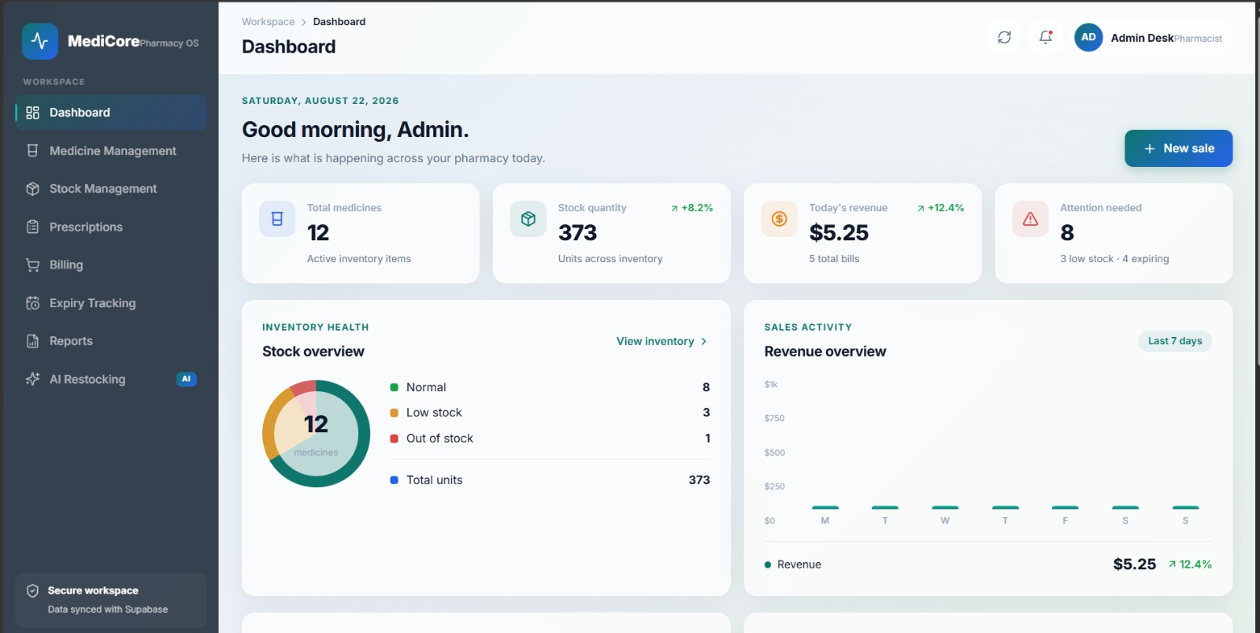
Figure 4.1 – MediCore dashboard showing inventory health, stock quantity and revenue indicators.

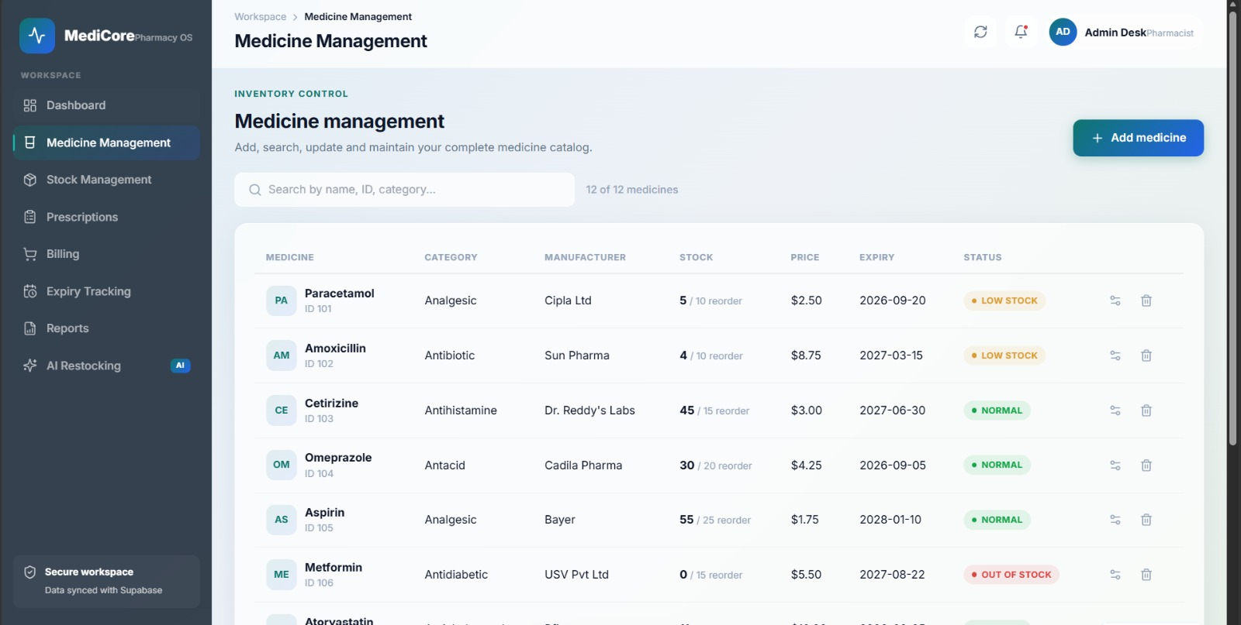
Figure 4.2 – Medicine Management screen showing medicine records, stock, price, expiry and status.

4.3 Test Plan & Verification .....................................
The test plan supplied in the project presentation contains twelve functional cases. Each case compares the expected behavior with the actual demonstrated output. The supplied test matrix records PASS for all twelve cases.
Table 4.2 – Test Plan and Verification
Requirement / Test Case | Test Method | Acceptance Criterion
Login with correct credentials | Enter valid username/password | Access granted
Login with incorrect credentials | Enter invalid credentials | Access denied
Add new medicine | Enter valid medicine record | Medicine added successfully
Search existing medicine | Search valid medicine | Medicine details displayed
Search non-existent medicine | Search invalid medicine | Medicine not found
Update medicine price | Edit existing record | Price updated
Delete medicine | Delete selected record | Medicine removed
Generate bill | Enter purchase details | Bill generated with total
Low-stock alert | Set quantity below reorder level | Alert displayed
Expiry date check | Use expired/expiring records | Expiry status displayed
Inventory report | Generate inventory report | Complete report generated
AI restocking recommendation | Evaluate stock + sales condition | Suggestion provided

4.4 Results ......................................................
The demonstration results show the principal workflow screens functioning together: dashboard, medicine management, expiry tracking, billing, prescription management, reports, and restocking recommendations. The test matrix records all twelve functional test cases as PASS.
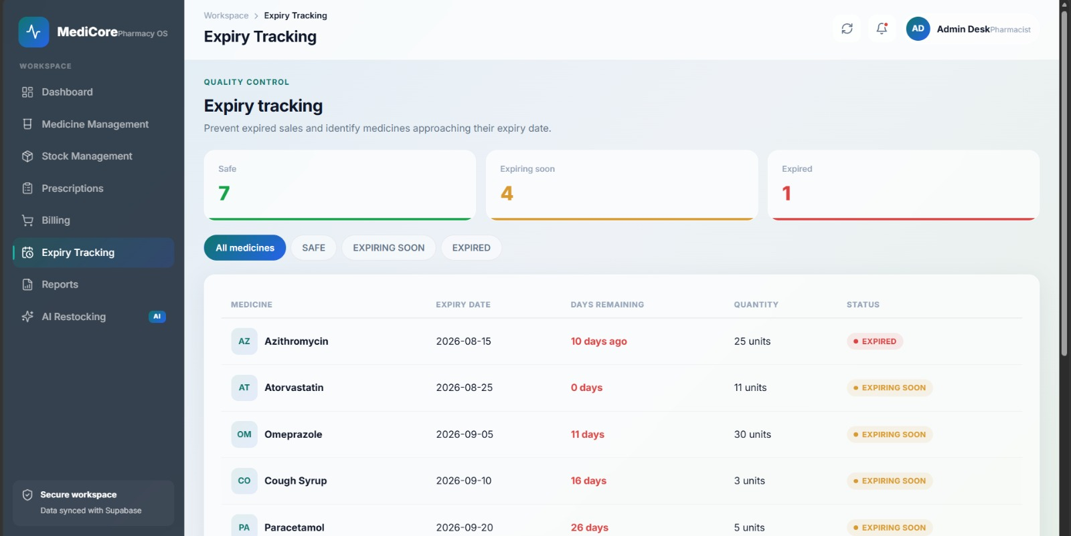
Figure 4.3 – Expiry Tracking screen identifying expired and expiring-soon medicines.

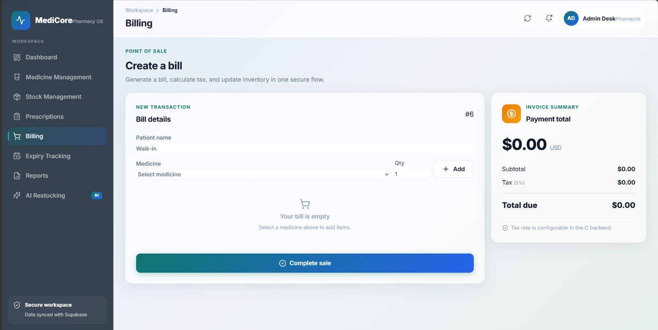
Figure 4.4 – Billing screen for creating a transaction and calculating the invoice summary.

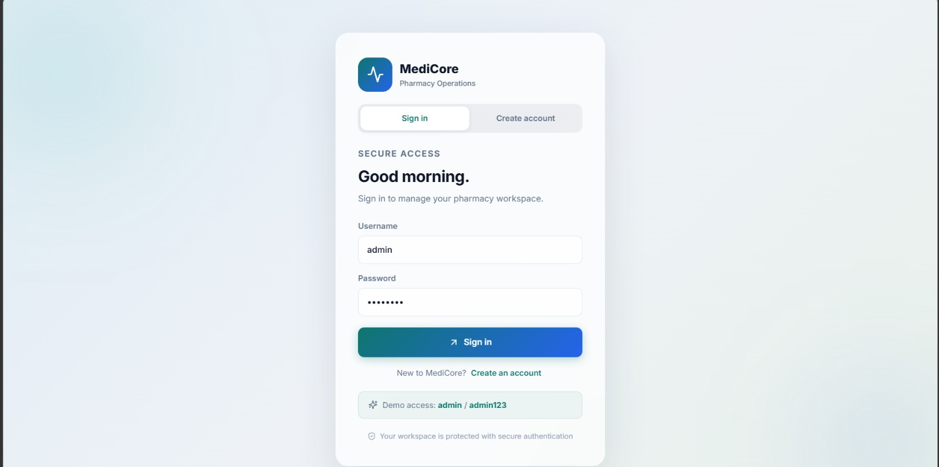
Figure 4.5 – MediCore login screen used for secure workspace access.

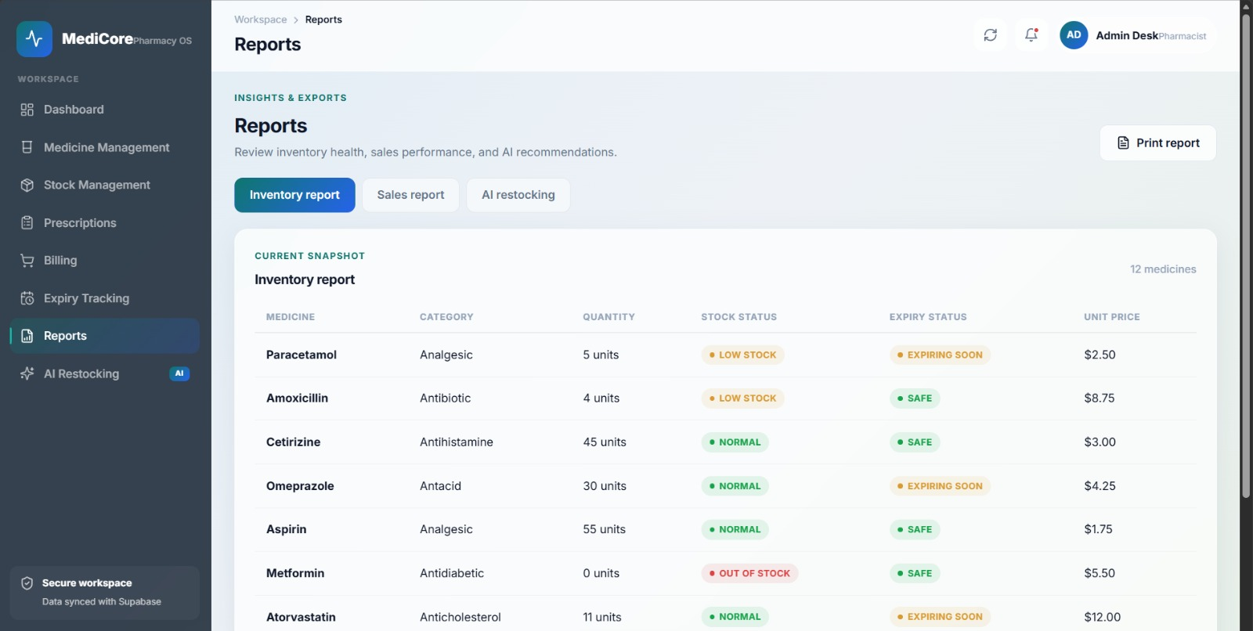
Figure 4.6 – Reports screen showing inventory information and status.

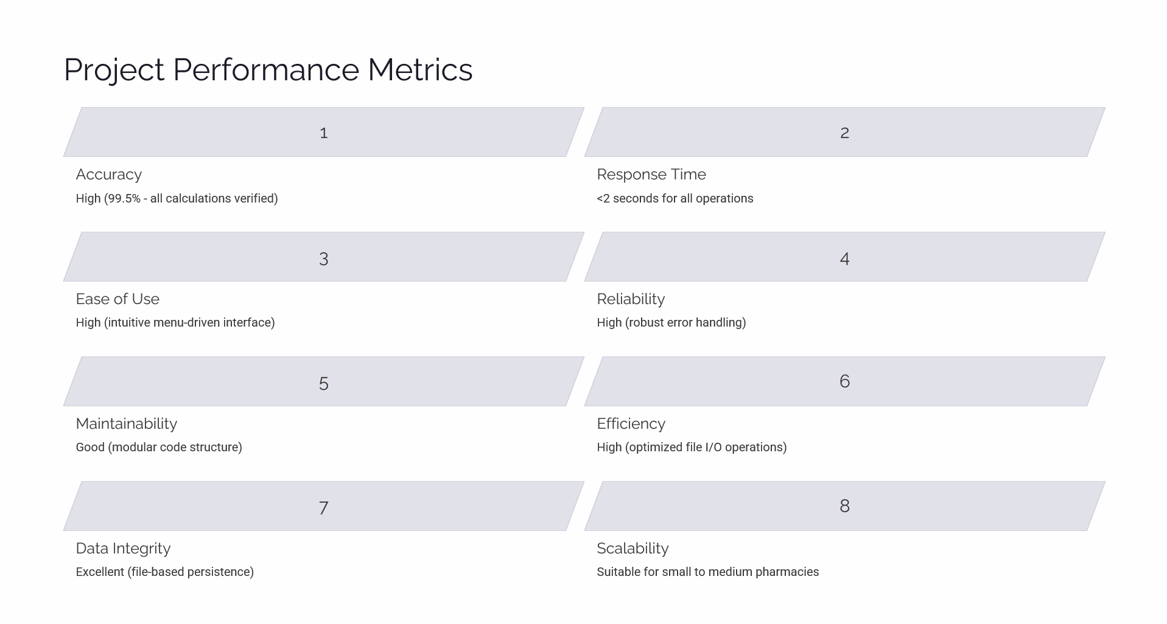
Figure 4.7 – Project performance metrics supplied in the presentation.

4.5 Data Analysis & Engineering Judgment .........................
The supplied performance slide reports high calculation accuracy, response time below two seconds for demonstrated operations, good maintainability, excellent data integrity for the project’s persistence approach, high reliability, and suitability for small-to-medium pharmacy use. These figures are project presentation metrics and should be understood as demonstration results rather than independent clinical or production validation.
The twelve-case functional test matrix provides the strongest direct verification evidence available in the supplied materials: each listed case has matching expected and actual outcomes and is marked PASS. The result supports the conclusion that the demonstrated core functions met their defined test expectations.

4.6 Comparison with Existing Solutions & Achievement of Objectives ...
Table 4.3 – Objective Achievement
Objective | Evidence | Achievement
Centralized medicine inventory | Medicine Management screen and record functions | Fully Achieved
Real-time / current stock monitoring | Stock status and low-stock indicators | Fully Achieved
Automated billing | Billing screen and passed bill-generation test | Fully Achieved
Expiry tracking | Expiry screen and passed expiry test | Fully Achieved
Prescription management | Prescription module in system architecture and interface | Fully Achieved
Reports | Reports screen and report test case | Fully Achieved
AI-assisted restocking | Recommendation module and passed test case | Fully Achieved

4.7 Strengths & Limitations ......................................

Strengths
• Integrates several pharmacy operations into one workflow.
• Uses core C programming concepts in a practical application.
• Provides visible stock and expiry status information.
• Restocking logic is transparent and explainable.
• Functional testing covers authentication, records, billing, alerts and reports.

Limitations
• Current implementation is a prototype and is not presented as a production pharmacy system.
• Rule-based restocking does not provide advanced demand forecasting.
• Flat-file storage is less scalable than a production database.
• Barcode, QR, cloud synchronization and automated supplier ordering are not part of the current scope.
• Sensitive prescription information requires stronger encryption, access control and audit mechanisms before real-world deployment.

4.8 Project Planning, Roles & Budget .............................
Table 4.4 – Project Roles
Student | Assigned Responsibility | Actual Contribution
KEERTHAN M | System design and integration | Core implementation and integration
MITHRAN K | Inventory / stock workflow | Stock and expiry verification
MOHAMED ASHFAQ M | Billing workflow | Billing verification
JESHONE PRINCE M | Prescription workflow | Prescription testing
MITHUN KRISHNA S | Reports / restocking | Report and recommendation verification

Table 4.5 – Project Budget
Item | Estimated Cost | Actual Cost
Development software / compiler | Existing / no additional project cost | ₹0
Documentation / printing | Academic requirement | As incurred
Computer / laboratory access | Existing resource | ₹0 additional
External hardware | Not required for current prototype | ₹0

CHAPTER 5
CONCLUSION, FUTURE WORK AND REFLECTION

5.1 Conclusion ...................................................
The AI-Based Medical Inventory and Prescription Management System successfully demonstrates an integrated pharmacy-management workflow through the MediCore Pharmacy Operations System. The project brings medicine records, stock monitoring, billing, prescription information, expiry tracking, reports, and rule-based restocking recommendations into a coherent system.
The project also demonstrates how C programming concepts such as structures, arrays, functions, loops, conditional statements, switch-case menus, and file handling can be combined to solve a practical engineering problem. The supplied twelve-case test matrix records all cases as PASS, while the presentation provides interface outputs and project performance metrics.

5.2 Future Work ..................................................
• Barcode scanner integration for faster medicine identification.
• QR-code based billing and payment workflows.
• Cloud database and multi-location pharmacy support.
• Mobile application for customer medicine search and ordering.
• Hospital integration for prescription verification.
• Machine-learning demand forecasting using historical sales.
• Email or notification alerts for low stock and expiry.
• Stronger role-based access, encryption, audit trails and backup mechanisms.

5.3 Professional Learning & Individual Reflection ................

New Knowledge Acquired
• Applying structures to model real-world entities such as medicines, bills and prescriptions.
• Using file I/O to preserve application data across sessions.
• Designing modular functions and integrating multiple modules.
• Testing normal, invalid and boundary conditions.
• Explaining a rule-based recommendation system without incorrectly claiming machine learning.

Engineering & Professional Skills Developed
• System decomposition and requirement mapping.
• Debugging and integration testing.
• Technical documentation and presentation.
• Team coordination and responsibility sharing.
• Engineering judgment based on requirements, constraints and test evidence.

Individual Reflections
KEERTHAN M

The most difficult part was integrating several modules while keeping data consistent. I focused on system design and integration so that medicine, stock, billing and reports followed a common data flow. I learned to test module interactions instead of checking functions only in isolation. If the project were repeated, I would design the persistence layer and interfaces even earlier.

MITHRAN K

The stock and expiry functions required careful handling of quantities and dates. Testing low-stock and expiry conditions helped me understand the importance of boundary cases. I learned how small changes in a record can affect several screens and reports. I would improve the validation logic further in a future version.

MOHAMED ASHFAQ M

Billing required accurate quantity and price processing and had to remain consistent with inventory updates. Working on this part improved my understanding of structures, calculations and validation in C. I learned that an apparently simple billing operation becomes a system-level operation when stock is also affected. I would add richer invoice and payment handling in a future version.

JESHONE PRINCE M

Prescription management showed me that data organization is important when records contain different fields and relationships. I learned to separate prescription information from general inventory data and to think about controlled access. The project also improved my understanding of testing and documentation. I would add stronger privacy controls in a future version.

MITHUN KRISHNA S

Reports and restocking recommendations required information from several parts of the system. I learned how to convert business conditions into clear programming rules and how to present the reason behind a recommendation. The project improved my confidence in debugging and technical presentation. I would add historical demand analysis to make future recommendations more informative.

REFERENCES .......................................................
[1] Kernighan, B. W., and Ritchie, D. M., The C Programming Language, 2nd Edition, Prentice Hall.

[2] Saveetha Institute of Medical and Technical Sciences, CSA0202 – C Programming course materials and capstone report guidelines.

[3] AI-Based Medical Inventory and Prescription Management System, CSA0202 – C Programming project presentation, 2026.

[4] ISO/IEC 25010, Systems and software Quality Requirements and Evaluation (SQuaRE) – System and software quality models.

[5] World Health Organization (WHO), Good Pharmacy Practice and quality-related pharmacy guidance, as referenced in the project presentation.

[6] MediCore Pharmacy Operations System – project interface screenshots, demonstration outputs and testing material supplied for capstone documentation.

Note: The report uses the project presentation and supplied implementation material as the primary evidence for project-specific results and screenshots. No claim in this report should be interpreted as clinical validation or production deployment approval.

APPENDICES ....................................................... 25

Appendix A – Representative C Data Structures
#define MAX_MEDICINES 200
#define MAX_PRESCRIPTIONS 200
#define MAX_BILLS 200
#define MAX_BILL_ITEMS 30
#define MAX_SALES 500
typedef struct {
int medicine_id;
char name[100];
char category[50];
char manufacturer[100];
int quantity;
int reorder_level;
float price;
char expiry_date[20];
} Medicine;
typedef struct {
int prescription_id;
char patient_name[100];
char patient_contact[50];
char doctor_name[100];
char medicine_name[100];
char dosage[50];
int quantity;
char prescription_date[20];
} Prescription;

Appendix B – Representative Restocking Rule
if (current_stock <= 0) {
recommend RESTOCK;
} else if (current_stock < reorder_level &&
recent_sales > average_sales) {
recommend RESTOCK;
} else if (current_stock < reorder_level) {
recommend RESTOCK;
} else {
recommend MONITOR;
}
The project material explicitly describes this as a transparent rule-based recommendation rather than machine learning.

Appendix C – Testing Summary
Table A.1 – Testing Summary
Test Area | Cases | Result
Authentication | 2 | 2 PASS
Medicine operations | 4 | 4 PASS
Billing | 1 | 1 PASS
Stock / expiry | 2 | 2 PASS
Reports | 1 | 1 PASS
AI restocking | 1 | 1 PASS
Total | 12 | 12 PASS

Appendix D – Project Output Screens

Figure A.1 – MediCore secure login screen.


Figure A.2 – Medicine Management output.


Figure A.3 – Expiry Tracking output.


Figure A.4 – Billing output.


Figure A.5 – Reports output.

Appendix E – Capstone Project Outcome Mapping
Table E.1 – Capstone Project Outcome Mapping
Outcome Evidence | SO / Area | Location in This Report
Complex engineering problem formulation | SO1 | Ch. 1, Ch. 2
Engineering design under constraints | SO2 | Ch. 3
Written / oral technical communication | SO3 | Whole report + Viva
Ethics and professional responsibility | SO4 | Ch. 3.7
Teamwork and leadership | SO5 | Ch. 4.8
Experimentation, analysis, engineering judgment | SO6 | Ch. 4.3–4.6
Independent acquisition of new knowledge | SO7 | Ch. 5.3
Standards | SO2 | Ch. 3.2
Sustainability / societal impact | SO2/SO4 | Ch. 3.7
Risk assessment and mitigation | SO2/SO4 | Ch. 3.7
Security considerations | Relevant SO | Ch. 3.7
Integrated/system-level engineering | SO1/SO2 | Ch. 3.5
Project planning and management | SO5 | Ch. 4.8
Individual contribution | SO1–SO7 | Contribution Statement + Ch. 4.8

